If you have opened this document directly from the Intranet, Use File >> Save As to create a copy in your own folder structure. Then close this window and reopen the document you have created to edit it.
If you receive an error message when you try to Save As, close this window. Right click on the link, then select Copy Target As to download the file to your own folder structure.
NOTE: All the instructions in this template are written using the “Commentary” style. You can hide and redisplay the the instructions by clicking the “Show-Hide Instructions” button in the QIP toolbar. When you have finished your document, you can permanently remove instructions by using the "Delete commentary" button in the QIP toolbar. Do not correct any pagination issues until after you have hidden or removed commentary.
Use the page setup buttons in the QIP toolbar if you need to convert the document from A4 to letter or vice versa.
This template contains a number of predefined fields which will automatically update the some of the information in this document. To complete the fields select File>>Properties to:
- enter the project name in the Subject field (for the Project Name on this page and in the header).
- enter your business entity name in the Company field (for the copyright statements)
- enter the copyright year(s) in the Category field
- enter your name in the Author field
Use Edit>>Select All, then press F9 to update fields in the body of the document. Press Print Preview to update fields in page headers and footers. You can also copy and paste these fields into the body of your document.
Remove any sections that are inappropriate to describing the system under development

1 Analise e Design

1.1 Objetivo

Mostrar o que é necessário para satisfazer as necessidades do cliente. É uma ponte entre os requisitos identificados e as técnicas para transformar esses requisitos em funcionalidades, bem como mostrar a maneira de fazer isso.

1.2 Principais responsabilidades do sistema

Fornecer ao usuário informações coerentes com o decorrer da utilização do sistema, disponibilizando informações precisas e atualizadas, conforme os dados forem sendo inseridos para cadastros e gerações diversas, tanto de cardápios quanto de ordens de produção e pedidos de compra.

1.3 Visão Geral do Sistema

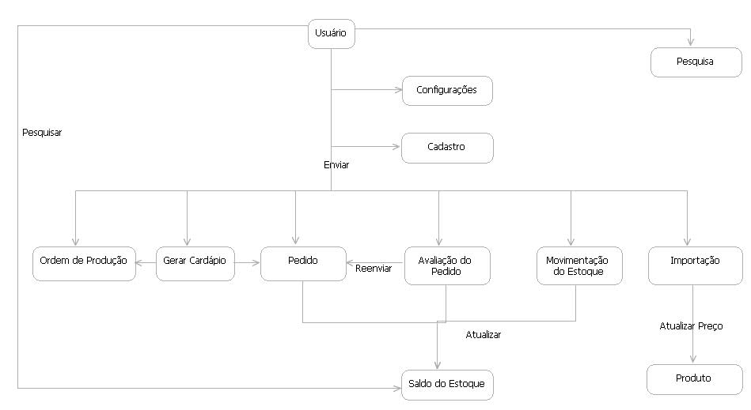
Figura 1 – Visão Geral do SICON

Provide a complete list of all documents referenced elsewhere in the Design Specification. Identify each document by title, report number (if applicable), date, and publishing organization. Specify the sources from which the references can be obtained. This information may be provided by reference to an appendix or to another document.

1.4 Visão Externa da Arquitetura do Sistema

This section describes in detail the external part of the architecture. In particular, it explains the collaboration with other systems, the supported protocols, messages, etc.
Implementar um software que satisfaça as necessidades básicas do usuário, que são:
- Proporcionar um ambiente fácil de trabalhar;
- Realizar cálculos complexos para a geração do cardápio;
- Controle do Estoque baseado nas gerações de cardápios.

Put the system in context of the enterprise. In particular, it is important to show the collaboration with other systems.
Describe the supported communication protocols.

1.4.1 Layout de Telas

1.4.1.1 Tela de Login do Usuário

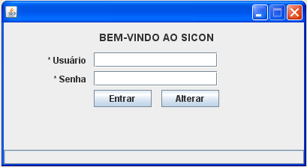
Figura 2 – Tela de Login

1.4.1.2 Tela padrão de Pesquisa
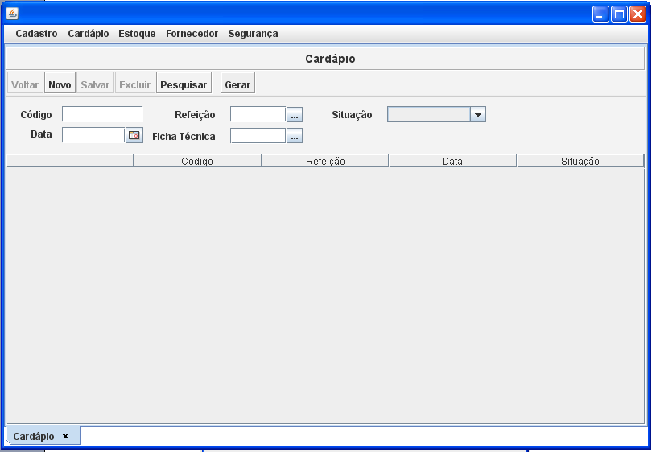
Figura 3 – Tela de Pesquisa

1.4.1.3 Tela Padrão de Cadastro

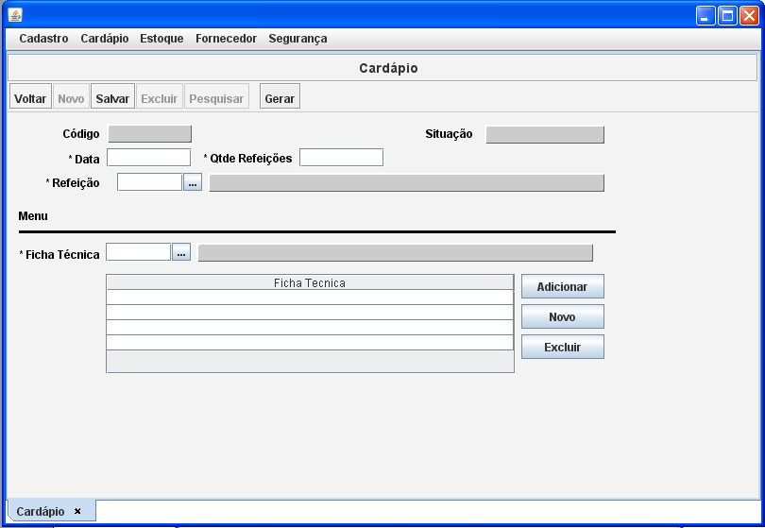
Figura 4 – Tela de Cadastro

1.4.1.4 Tela de Geração de Cardápio
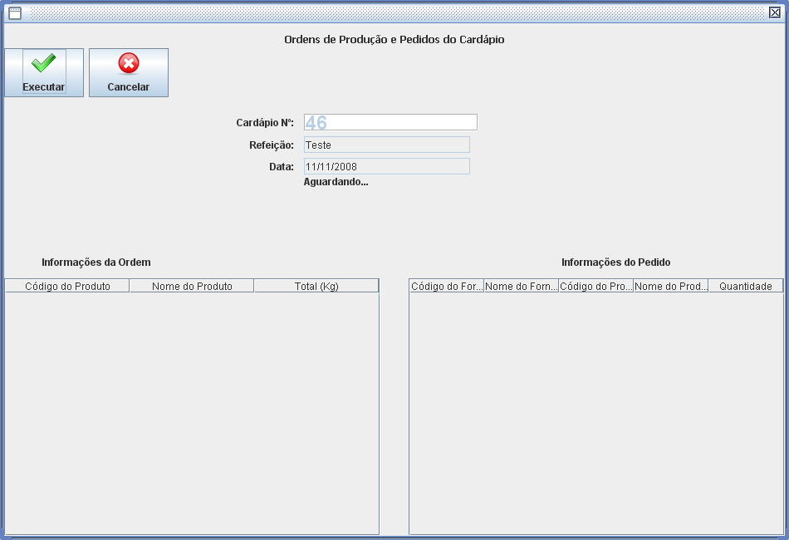
Figura 5 – Tela de Geração de Cardápio

1.4.1.5 Tela de Consulta de Saldo do Estoque

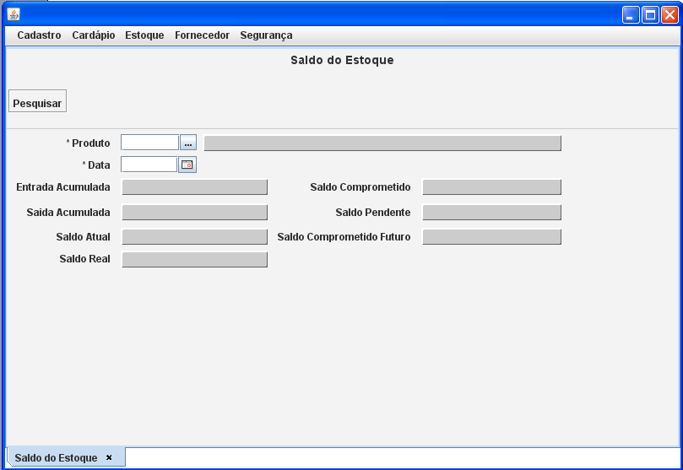
Figura 6 – Tela de Saldo do Estoque

1.4.1.6 Tela de Avaliação do Pedido

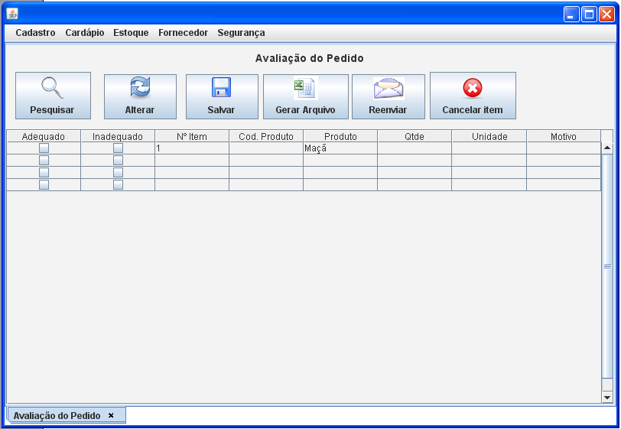
Figura 7 – Tela de Avaliação do Pedido

1.4.1.7 Tela de Importação de Preços

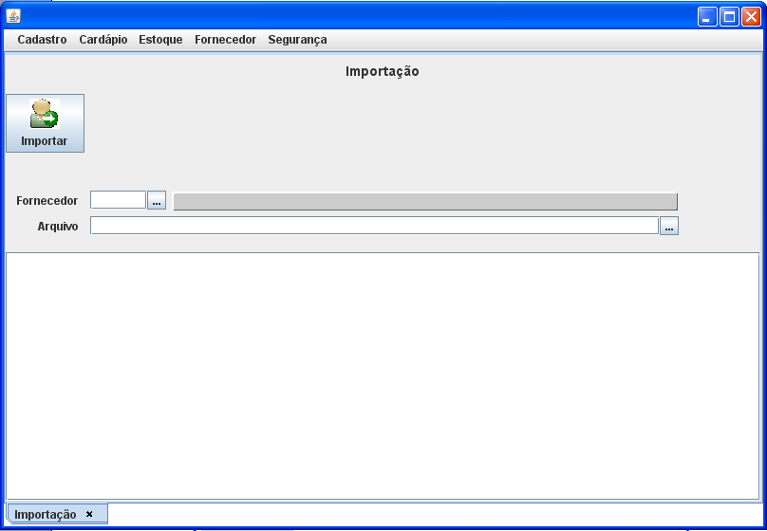
Figura 8 – Tela de Importação de Preços

1.4.1.8 Tela de Configurações

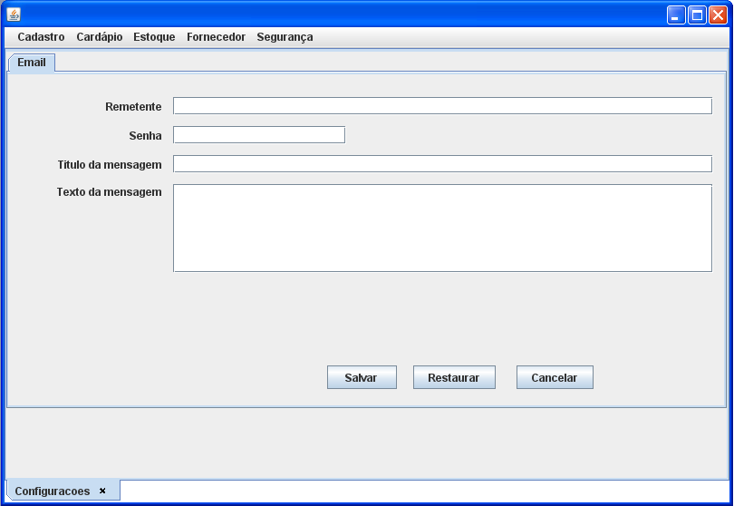
Figura 9 – Tela de Configurações
Describe in detail the reports produced by the system.
Sequences of screen shots that depict use case behaviour, enacting some part of a scenario.
Mock-up of any user interface, such as screens or reports.

1.5 Visão Interna da Arquitetura

This section describes the architecturally significant parts of the design model, such as its decomposition into subsystems and packages. And for each significant package/components, its decomposition into classes and class utilities.

1.5.1 Arquitetura Multicamadas

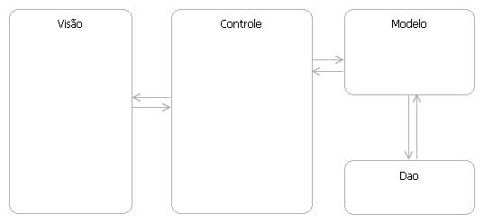
Figura 10 - Arquitetura

1.6 Especificações do Sistema

Describe the overall decomposition of the design model in terms of its components. If the architecture enforces a Component Based paradigm, then you must show the main components, otherwise, it is sufficient to show the main packages and the inter-dependencies. Presented parts should be allocated within the corresponding architecture layer. Packages, Components that span multiple-layers should not be allowed.
List the adopted standards, such as: JMS, JDBC, how this design adheres to R2 standards, etc.

1.6.1 Especificação de Software Detalhada

O Sistema de Controle Nutricional roda somente em máquinas que dispunham do J2SE 6.0, ou superior, pois existem componentes únicos, os quais não estão disponíveis em versões anteriores.

Provide the software specifications for the new system.

1.6.2 Especificação de Hardware Detalhada

O Sistema de Controle Nutricional roda em máquinas de qualquer gênero ou marca, porém com o mínimo de 1 GHZ de processamento e 512 MB de memória ram. Essa configuração é a mínima necessária para que a máquina virtual do Java rode sem problemas.

Model that is used to show the major system inputs, outputs, and procedures.
Bridges the gap between the user’s description of what they need (independent from the technical solution) and the technical design (solution dependent). Use Case Realizations can be in a narrative form or visual, such as sequence and collaboration diagrams. The difference between these diagrams in the Analysis Phase versus the Design Phase is that in Design, these Use Case Realizations take into account how the use case is implemented in the system. Therefore, one Use Case may have different Use Case Realizations for alternative solutions.

1.7 DIAGRAMA de Classes

A class diagram shows a set of classes, interfaces, collaborations and their relationships. These diagrams are the most common diagram found in modelling object-oriented systems. Class diagrams address the static design view of a system.
This section describes one or more physical network (hardware) configurations on which the software is deployed and run. It is a view of the Deployment Model. At a minimum for each configuration it should indicate the physical nodes (computers, CPUs) that execute the software and their interconnections (bus, LAN, point-to-point, and so on.)

1.8 Dicionário de Dados

(EM DESENVOLVIMENTO)

The Logical Data Model is a high level data model derived from the Conceptual Data Model.
System-independent mapping: The conceptual data model is mapped to the standard data elements in the data dictionary. This does not consider any specific characteristics or special cases that apply to the particular data storage method.

1.9 Estrutura do Banco de Dados
The Database Structure is part of the Logical Data Model. It may also be in the form of an Entity Relationship Diagram, representing the structure of a database.
In creating the Logical Data Model, tailor data schemas to a specific data storage or Database Management System by applying specific rules and constraints for the chosen data storage method. The result is often specific statements, such as DDL, to specify the database structures.

1.9.1 Modelo Relacional
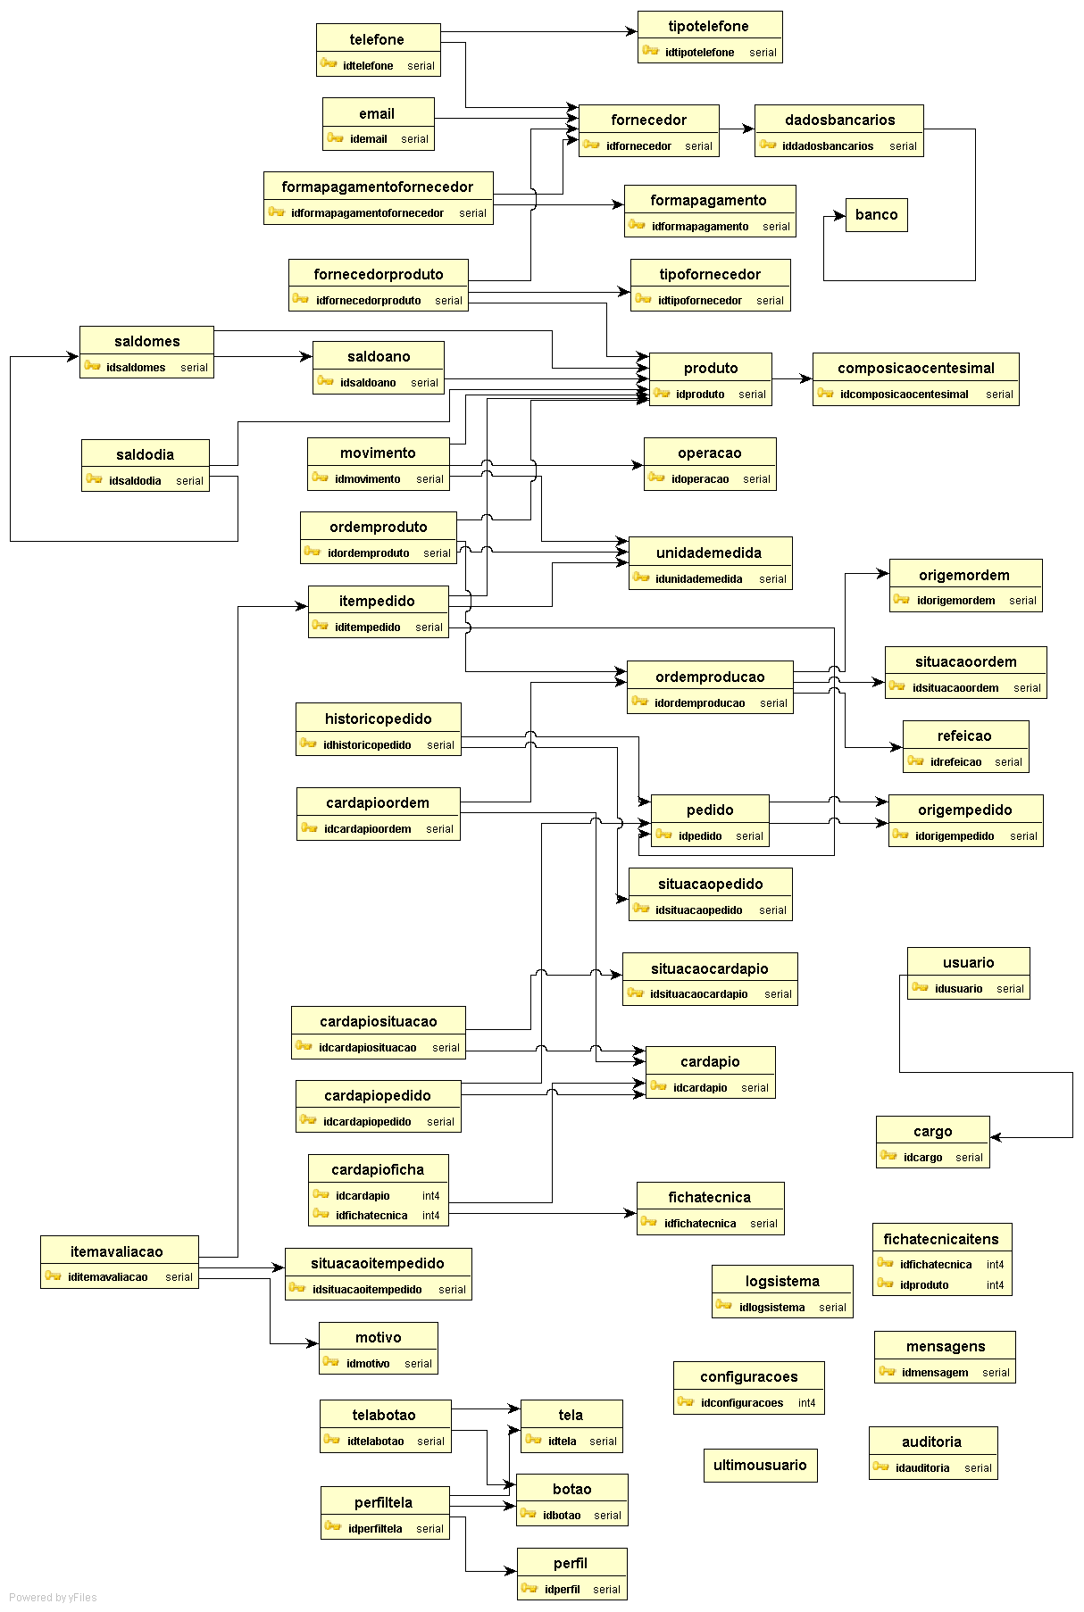
This Entity Relationship diagram represents the Physical Data Model. It provides specific storage structures and access paths for the database files to achieve good performance for the use cases or functional requirements, system behaviours.
The Physical Data Model takes into account who, what, where, and how often information will be added, changed, deleted, queried.
To accommodate how the information is used, the Physical Data Model usually includes various types of indexing, clustering on storage devices, linking, pointers, hashing methods, security and referential integrity rules.
The following non-functional requirements help determine physical data model design options: response time, space utilization accounting for capacity and scalability requirements, transaction throughput (average number of transactions that can be processed per minute, measured under peak conditions) for acceptable performance, entitlement, and security.

